

GENERAL PROCEDURE

for
liquid penetrant testing

DOCUMENT NUMBER: | IQMS-pT-P-001
REVISION: | 00
DOCUMENT DATE: | 21 June 2017

18 Greybeard Road, Sandrift-North, Milnerton, 7441
Tel / Fax: +27(0) 21 555 2973 Mobile: +27(0) 79 957 2869
Email: cpt@iqms.co.za Website: www.iqms.co.za
Contents
1. PURPOSE 3
2. SCOPE 3
3. REFERENCING CODE SPECIFICATIONS 3
4. DEFINITIONS AND ABBREVIATIONS 3
5. REFERENCES 4
6. REQUIREMENTS 4
6.1 Safety 4
6.2 Prerequisites 4
6.3 Precautions and Limitations 4
6.4 Personnel Requirements 4
6.5 Equipment and Consumable Requirements 4
6.6 Location and Component Identification 5
6.7 Control of Contaminants 5
6.8 Techniques 5
6.9 Surface Preparation 5
6.10 Penetrant Application 6
6.11 Penetrant Dwell Time 6
6.12 Excess Penetrant Removal 6
6.13 Developer Application 7
6.14 Developer Dwell Time 7
6.15 Interpretation 7
6.17 Evaluation 8
6.18 Documentation 8
6.19 Post-examination Cleaning 8
APPENDIX 1 - ASME B31.1 2014 9
APPENDIX 2 - ASME B31.3 2014 11
APPENDIX 3 - ASME VIII 2015 12
APPENDIX 4 - AWS D1.1 2010 16
APPENDIX 5 - SAMPLE REPORT 17
PLEASE NOTE
This Document replaces all previous discussions, understandings and revisions of this written procedure for Liquid Penetrant Testing utilized by IQMS Group.

PURPOSE

This Procedure details the method to perform Liquid Penetrant Testing by Authorized Personnel on behalf of IQMS GROUP.

SCOPE

Applicable to all ferromagnetic materials which includes product forms of welds, castings and forgings when the Procedure Code is:

ASME V (2015) | ASME Boiler and Pressure Vessel Code, Section V: Non-Destructive Examination  Article 6: Liquid Penetrant Examination  Article 24 SE165: Standard Practice for Liquid Penetrant Testing

REFERENCING CODE SPECIFICATIONS

The applicable version and addendum of the referencing code specifications shall be stipulated by the client, AND a working copy may be requested by the Company from the client prior to conducting work under this procedure.

ASME B31.1 (2014) | Power piping
ASME B31.3 (2014) | Process Piping
ASME VIII (2015) | ASME Boiler and Pressure Vessel Code, Section VIII, Div 1: Rules for Construction of Pressure Vessels
AWS D1.1 (2010) | Structural welding code

(Usually the latest/ current edition of a Code/Specification is applicable. Specific editions of the Codes/Specifications used, must be specified on the Report Sheet as the Customer may have specific requirements.)

DEFINITIONS AND ABBREVIATIONS

NDT | Non-Destructive Testing
PT | Liquid Penetrant Testing
Technician | A qualified PT Level II or III Technician authorized by the Company in accordance with IQMS-WP-001.
The Company | IQMS GROUP
UV | Ultra Violet light with nominal wavelength of 365nm (commonly called black light)

REFERENCES

IQMS-WP-001 | Written Practice for the Qualification, Internal Certification and Authorization of NDT Personnel.
IQMS-WP-002 | Written Practice for the Performance of NDT Equipment.

REQUIREMENTS

6.1 Safety

- Extreme caution shall be exercised as Liquid Penetrant materials can be flammable and/or emit hazardous and toxic vapor.
- Any additional manufacturer’s safety precautions must be observed.
- Prior to the commencement of work, all safety and regulatory safety standards as specified by the location of work (E.g. Refineries, Power stations, manufacturing, workshops, etc.) must be adhered to.
- Before any electrical equipment is used, the technician shall satisfy himself that there shall be no danger or hazard from fire as a result of any overheating or sparking.
- All equipment shall be certified as electrically safe prior to use.
- It is essential to ensure that adequate ventilation in confined areas is supplied.
- The use of an O2 Monitor (Oxygen Monitor) may be a requirement at certain work locations. Some work locations may require that the client provides an oxygen test prior to a vessel entry. Adequate ventilation is of utmost importance when performing a Magnetic Particle Inspection in confined spaced areas.
- The use of extraction fans may be necessary. A predetermined pre-job discussion and safety plan shall be agreed upon between the company and client prior to the commencement of work.
- Avoid contact with the UV lamp housing as it becomes extremely hot in use.
- All permits shall be completed in full when required by the client or site of work.
- Wet Floors: Slipping on a floor wetted with Magnetic Particle medium suspension may be possible. Exercise caution during the inspection to this regard. Ensure proper drainage of excess waste medium.

Prerequisites

Prior to any examinations performed, the technician shall ensure that all work permits, safety regulations and documented requests from client is in place and that all involved personnel is informed of the procedure to be followed.

Precautions and Limitations

- The Liquid Penetrant Testing method is an effective means for detecting discontinuities which are open to the surface only, of clean, nonporous metals and other solid materials.
- Fluorescent Penetrant examination shall not follow a colour contrast Penetrant examination.
- A retest with water washable Penetrants may cause loss of marginal indications due to contamination.

Personnel Requirements

All personnel performing PT, Evaluating and/or reviewing the test results shall be Level II or Level III Technicians authorized in accordance with the requirements of IQMS-WP-001. Level I personnel may provide assistance under the direct supervision of a Level II technician.

Equipment and Consumable Requirements

- All equipment used for Liquid Penetrant Testing shall be in a good working order and calibrated as stipulated in
- IQMS-WP-002.
- Penetrant materials used shall be from pressurized cans only. Bulk materials, self-mixed, tanks or any other form shall not be permitted. The expiration dates of all consumables shall be checked and may not be used if expired. The expiry dates of consumables and batch numbers shall be recorded on each report as used.
- Only Met-L-Chek, Chemetall, Chemserve or Magnaflux Penetrant materials may be used.
- Different ‘Families’ of consumables from different manufacturers shall not be inter-mixed.

Location and Component Identification

- Each weld or component shall be identified on a work request together with an inspection package. At each location a physical identification should be present, i.e. Plant Location Code (PLC).
- In cases where the inspection package and physical identification nomenclature cannot be reconciled, NO inspection shall be performed until resolution is provided by the Client.
- Where temporary identification is allowed, the operator shall ensure that the type of marking will remain present for any period of re-work, should repairs be necessary. The operator shall establish a zero reference datum related to some prominent feature of the item (e.g. Top Dead Centre), which shall be detailed in the inspection report.

Control of Contaminants

The Company shall obtain certification of contaminant content for all liquid Penetrant materials used on nickel base alloys, austenitic stainless steels, and titanium. These certifications (MSDS) shall include the Penetrant Manufacturers’ batch numbers and the test results obtained.

Techniques

Either one of the following four techniques may be used, depending on the type of discontinuity sought, temperature of material to be examined, material surface condition, geometry, roughness and light conditions:

- Visible, water washable
- Visible, solvent removable
- Fluorescent, water washable
- Fluorescent, solvent removable

All techniques shall make use of Solvent based (non-aqueous wet) developer.

Surface Preparation

- In general, satisfactory results may be obtained when the surface of the part is in the as-welded, as-rolled, as-cast, or as-forged condition. Surface preparation by grinding, machining, or other methods maybe necessary where surface irregularities could mask indications, but after such operations the surface shall be chemically etched to ensure that these operations did not peen over or closed any surface openings.

- Prior to each Liquid Penetrant examination, the surface to be examined and all adjacent areas within at least 25 mm shall be dry and free of all dirt, grease, lint, scale, welding flux, weld spatter, paint, oil, and other extraneous matter that could obscure surface openings or otherwise interfere with the examination.

- The part shall then be flushed with solvent remover and wiped clean with a clean, lint free cloth and left to dry via evaporation for a minimum of 5 minutes.

- Surface preparation by grinding, machining, or other methods may be necessary where surface irregularities could mask indications and shall meet the client or manufacturers recommendations.

- Surface preparation by grinding, machining or other metal smearing operations shall require client approval.
NOTE: These processes may decrease the effectiveness of the penetrant examination by smearing or peening over metal surfaces and filling discontinuities open to the surface, especially for soft materials such as aluminium, magnesium, and beryllium alloy.
- Acid solutions /etchants may be used routinely for descaling part surfaces. Descaling is necessary to remove oxide scale, which can mask surface discontinuities and prevent penetrant from entering. Acid solutions /etchants are also used routinely to remove smeared metal that peens over surface discontinuities. Such etchants should be used in accordance with the manufacturer’s recommendations and shall require client approval.

Penetrant Application

- Penetrant Testing may only be performed on surfaces where the temperature is not less than 5°C but not greater than 50°C or in accordance with Consumable Manufacturer recommendations. The component temperature shall be noted at the commencement, during and at the completion of inspection. Surfaces outside this temperature range (or where the temperature fluctuates outside this range) shall not be inspected without re-qualification. Re-qualification shall involve a separate technique to be compiled that proves the method of test performed under the new temperature conditions, using an artificially flawed reference specimen under the same temperature conditions.

- Penetrant shall be applied to the entire inspection area by direct aerosol spray from a well agitated can.

- The Penetrant must remain wet throughout the dwell time and repeated applications of Penetrant may be necessary. Should the Penetrant be allowed to dry or separate (bead) on any part of the surface the inspection must be repeated commencing with surface preparation.

Penetrant Dwell Time

- The minimum Penetrant dwell time for all components and Techniques shall be 10 minutes.

- The dwell times may be increased due to on-site environments which may lead to difficulty in penetration of the penetrant.

- The maximum dwell time shall not exceed 2 hours.

Excess Penetrant Removal

- Excess Penetrant shall be removed under the correct light intensity requirements:

Visible Penetrants | A white light intensity of a minimum of 1076 lux as measured at the test surface shall be adhered to.
Fluorescent Penetrants | Ultraviolet light intensity conditions shall be a minimum of 1000µW/cm² as measured at the test surface. Visible ambient light intensity shall be less than 20 lux.

- Solvent wipe technique:
After the pre-requisite dwell time excess solvent removable penetrant shall be removed by wiping the inspection surface in a single direction with absorbent paper. When most traces of the Penetrant have been removed, the inspection surface shall be further wiped with absorbent paper lightly moistened with cleaner / remover. Flushing the inspection surface with cleaner / remover is expressly forbidden.

- Water wash technique:
After the pre-requisite dwell time excess water washable Penetrant shall be removed with a coarse water spray at a pressure not exceeding 275kPa (40 psi) and a water temperature ranging between 10°C to 38°C. The wash angle shall be oblique and at a distance of approximately 300mm away. Over-washing the test surface shall be avoided.

After excess Penetrant removal, prior to application of developer, drying is to be accomplished by wiping the part with clean, lint free paper towels until part is dry to the touch. The part shall further be allowed to dry by normal evaporation at ambient temperatures for at least 5 minutes, but no longer than 10 minutes, prior to the application of developer.

Developer Application

- Non-aqueous-wet developer shall be used for all techniques.

- Developer shall be applied to a dry surface within the times specified in paragraph 12 above.

- Prior to applying suspension type wet developer to the surface, the developer must be thoroughly agitated to ensure adequate dispersion of suspended particles.

- The developer shall be applied by spraying a thin uniform coating over the entire inspection area directly from a well agitated aerosol spray can.

- Drying of developer shall be by normal evaporation.

Developer Dwell Time

Developing time for final interpretation begins as soon as the developer coating is dry.

Interpretation

- The operator shall identify an indication as false, non-relevant, or relevant. False and non-relevant indications shall be proven false or non-relevant. Interpretation shall be carried out to identify the locations of indications and the character of the indications.

- Final Interpretation
Final interpretation shall be made not less than 10 min and no more than 60 min after the developer coating is dry.

- Characterizing Indication(s)
The type of discontinuities is difficult to evaluate if the Penetrant diffuses excessively into the developer. If this condition occurs, close observation of the formation of indication(s) during application of the developer may assist in characterizing and determining the extent of the indication(s).

- Colour Contrast Penetrants:
With a colour contrast Penetrant, the developer forms a reasonably uniform white coating. Surface discontinuities are indicated by bleed-out of the Penetrant which is normally a deep red colour that stains the developer. Indications with a light pink colour may indicate excessive cleaning. Inadequate cleaning may leave an excessive background making interpretation difficult. A minimum light intensity of 100 fc (1076 Lx) is required on the surface to be examined to ensure adequate sensitivity during the examination and evaluation of indications. The light source, technique used, and light level verification is required to be demonstrated one time, documented, and maintained on file.

- Fluorescent Penetrants:
With fluorescent Penetrant, the process is essentially the same as with colour contrast Penetrant, with the exception that the examination is performed using an ultraviolet light, called a black light. The examination shall be performed as follows:
- It shall be performed in a darkened area.
- The examiner shall be in the darkened area for at least 5 min prior to performing the examination to enable his eyes to adapt to dark viewing. If the examiner wears glasses or lenses, they shall not be photosensitive.
- The mercury vapor black light shall be allowed to warm up for a minimum of 5 min prior to use or measurement of
- The intensity of the ultraviolet light emitted. Reflectors and filters should be checked and cleaned daily when in use. Cracked or broken filters shall be replaced immediately.
- The black light intensity shall be measured with a black light meter.
- A minimum of 1000 µW/cm² on the surface of the part being examined shall be required. The black light intensity shall be verified prior to the inspection, at least once every 8 hr, whenever the work station is changed, or whenever the bulb is changed.
- The Visible ambient light in the darkened area where fluorescent Liquid Penetrant examination is performed shall not exceed 20 lux.

Evaluation

- All relevant indications shall be evaluated in terms of the applicable Acceptance Standards specified by the client.

- Discontinuities at the surface will be indicated by bleed-out of Penetrant; however, localized surface irregularities due to machining marks or other surface conditions may produce false indications.

- Broad areas of fluorescence or pigmentation which could mask indications of discontinuities are unacceptable, and such areas shall be cleaned and re-examined.

Documentation

- Findings shall be interpreted and evaluated in accordance with the Referencing Code Specification specified by the client. See appendices 1, 2, 3 and 4.

- Reporting shall be done on a standard IQMS GROUP Report Sheet, unless otherwise required by the client (See Appendix 5).

Post-examination Cleaning

- When post-examination cleaning is required by the Client, it should be conducted as soon as practical after Evaluation and Documentation using a process that does not adversely affect the part.

- It shall be accomplished by flushing the part with Solvent Remover or cleaner and then wiped clean and dried with clean lint free paper towel or cloth.

- All traces of Liquid Penetrant media shall be removed.

- When a fluorescent method shall be used check the area of test using a UV light for any traces of Fluorescent materials, repeat the cleaning process if necessary.

APPENDIX 1 - ASME B31.1 2014

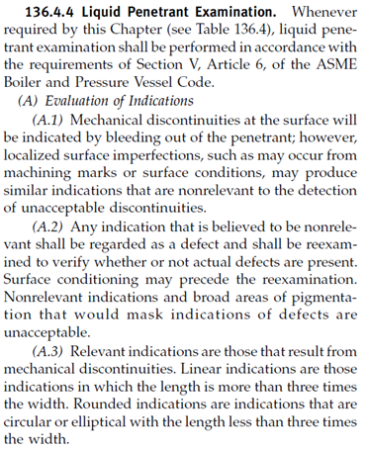
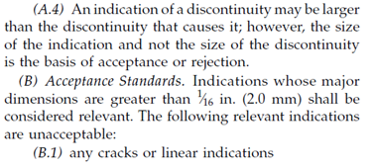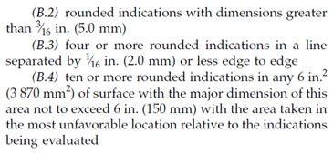

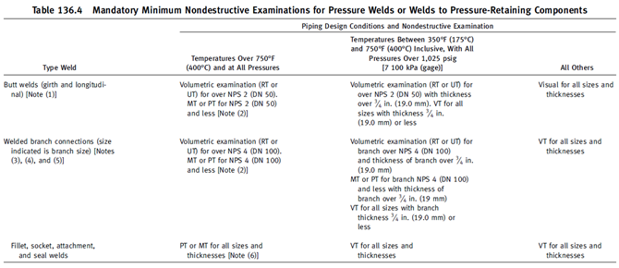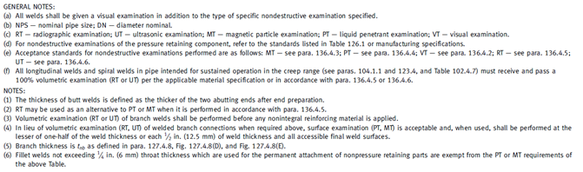

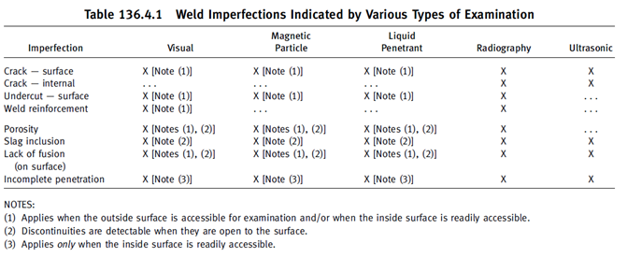

APPENDIX 2 - ASME B31.3 2014

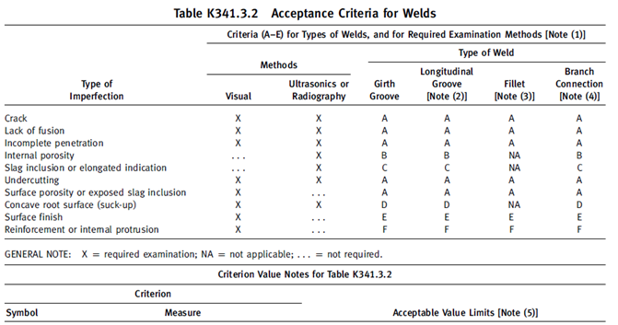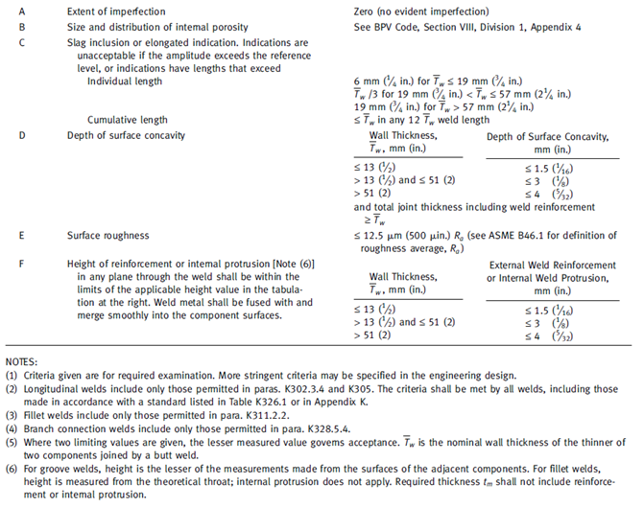

APPENDIX 3 - ASME VIII 2015

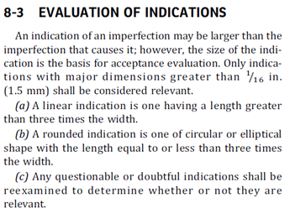

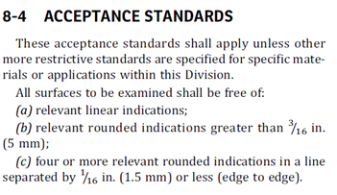

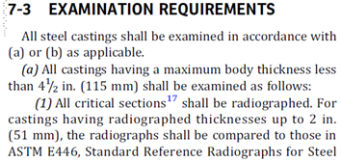
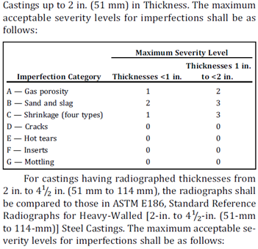
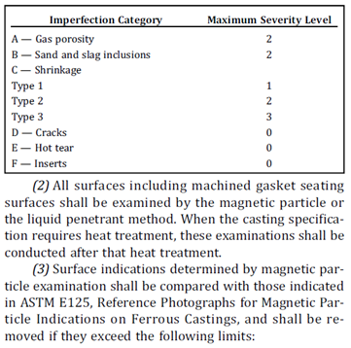
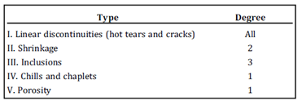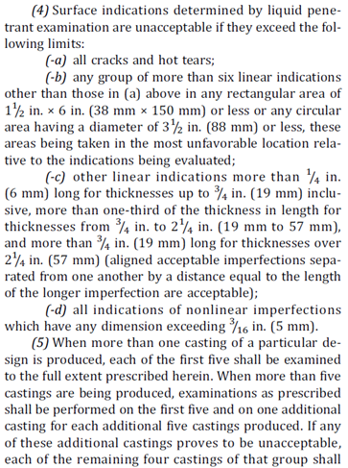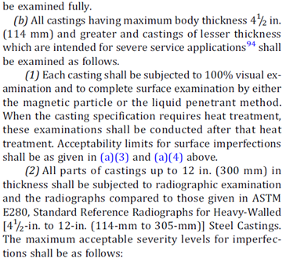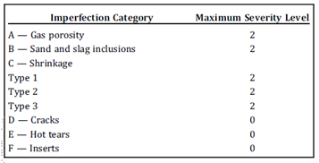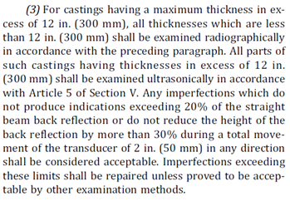

APPENDIX 4 - AWS D1.1 2010

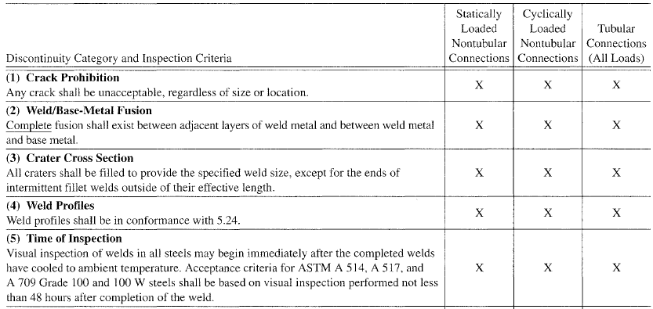
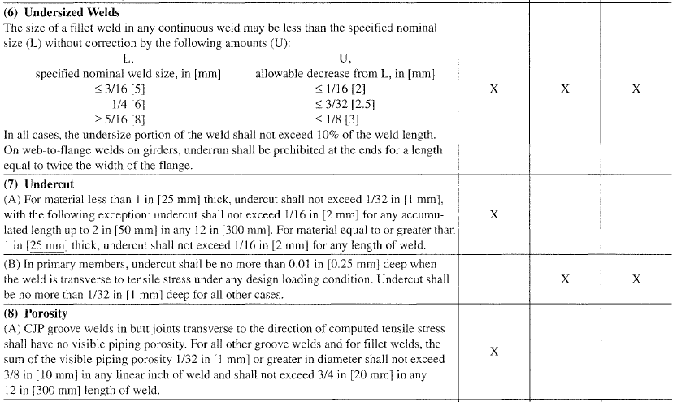
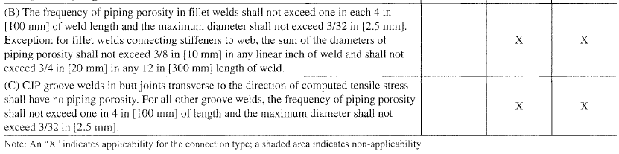

APPENDIX 5 - SAMPLE REPORT

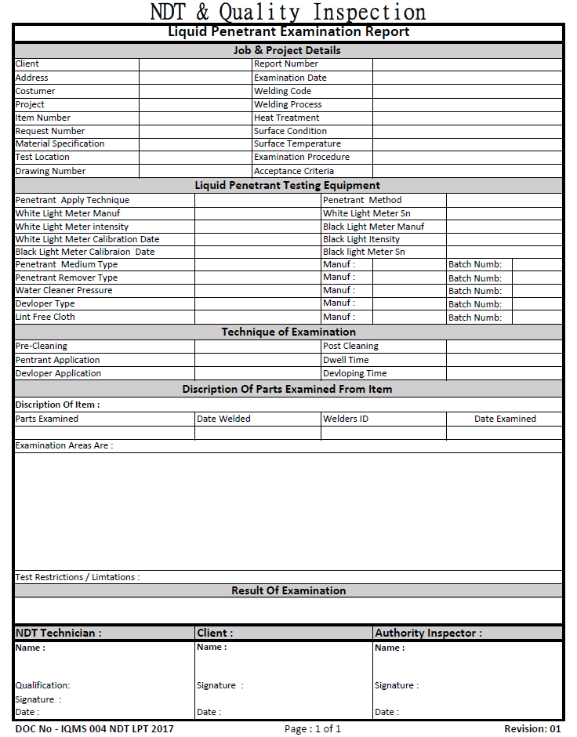

END

